(Approx. 918 words)

Weekly Meal Planner and Shopping List
By Tom Burt, Vice President
Sun City Summerlin Computer Club
www.scscc.club tomburt89134 (at) cox.net

This month I want to share a simple tool my wife and I use to plan each week’s meals and set up the supporting grocery shopping list. We’re getting on in years and eat most of our meals at home. The Word document we use makes it easy to get the job done.

Here’s a screenshot of a recent edition …
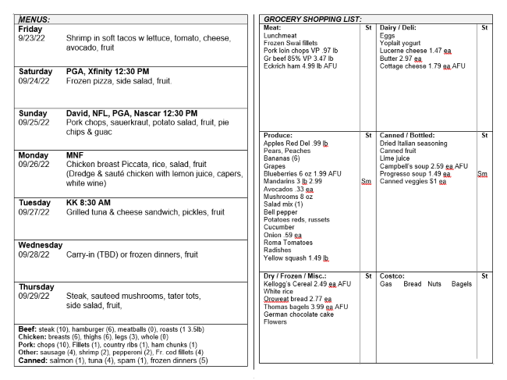

The layout is two columns: the left is each day’s meal plan, and the right is the shopping list. Because we shop for the groceries online on Wednesday and take delivery Thursday morning, it makes sense (to us) to start the meal week on Friday and go through to the following Thursday.

At the bottom of the meal plan side is a list of proteins in the refrigerator or the chest freezer. The counts shown are for meals. So, for example, hamburger (6) means 6 1-lb meals. This makes it easier to make daily meal choices and plan what items to buy. A freezer allows us to “buy when it’s on sale.” It also offsets some of the recent grocery price inflation and provides a cushion against supply shortages.

Each Tuesday, I copy the previous week’s meal plan document, rename the copy to have the current date (e.g., Menus_Groceries_2022-09-28.docx), and then edit it. I update the dates, note any key events for that week and update the protein inventory. Next, I look at the online ads for our two major local Las Vegas grocery stores. We favor the local Albertson’s store because we have a prepaid delivery plan there, but occasionally the Smith’s store has enough bargains to make a [free] pickup trip worthwhile.

The right side of the sheet above shows the shopping list after reviewing our local grocery store’s weekly online ad. I review the ad on Tuesday and note any specials and coupon items we’re interested in. Any sale prices are noted.

The page is designed to be folded in the center and torn into two parts. After shopping online, the meal plan side goes under a magnet on the refrigerator.

With all the above done, it’s time to focus on the meal plans. We have our “main” meal at about 1 PM and a light meal or snack early in the evening. The meal plans shown above focus on the midday meal.

My basic formula for each meal is protein, starch, vegetable, and fruit, with a nominal calorie count of about 800. Proteins include chicken, beef, pork, and canned or frozen fish. Starches include potatoes, white or wild rice, yams, pasta, and canned beans. Vegetables include fresh salad mix, tomatoes, cucumbers, broccoli, cauliflower, celery, and onions. The knack comes in putting together a series of meals that have variety, are easy to prepare, portion out well for two people, and, most importantly, are a pleasure to eat.

As an example, let’s look at Monday’s meal plan item.

Monday MNF

09/26/22 Chicken breast Piccata, rice, salad, fruit
(Dredge & sauté chicken with lemon juice, capers,
white wine)

The MNF reminds us that Monday Night Football is on. The meal is chicken breast dredged and sauteed with a sauce of white wine, capers, and lemon juice, served with white rice, a salad, and fruit. A check of the Monday menu the evening before reminds us to get a chicken breast out of the freezer and put it in the refrigerator to thaw. On shopping day, we also checked to ensure we have lemon juice and capers on hand (seldom a problem; these are staples).

During the cooler months, I often plan a soup or stew meal that will leave leftovers for a second day. An example might be spaghetti with meat sauce. It uses ground beef, onions, celery, zucchini, mushrooms, diced tomatoes, tomato sauce, red wine, parsley, oregano, and basil. The sauce can go over angel hair pasta for one meal and macaroni or penne for a second.

For one meal a week (usually Wednesday), we like carrying in, eating out, or having a canned soup or frozen dinner meal. Alas, since the COVID pandemic, eating out has been less attractive.

Sundays, our son David comes by for dinner. That meal plan has to feed three of us, so it’s a bit larger in scale. Here’s a typical example:

Sunday David, NFL, PGA, Nascar 12:30 PM
09/25/22 Pork chops, sauerkraut, potato salad, fruit, pie
chips & guac
(Sauté chops, add sauerkraut to pan, simmer on low)

The potato salad and pie are store-bought, and the sauerkraut is canned. Preparation is easy and can tolerate some time variation; our son lives about 15 miles away, so his arrival time varies.

If you’re interested in trying out my meal and shopping planner, you can download an example Word document from:

https://www.scscc.club/Gigabyte/Tom-Burt-Menus-Shopping-Example.docx.

My approach to meal planning and shopping may be too structured for some folks, and not everyone likes to cook as much as we do. But we find it makes things easier and helps keep down our food costs. I spend about an hour reviewing the grocery store ads on Tuesdays and then setting up the meal plan and shopping list. We do the online shopping on Wednesday mornings, which takes an hour to an hour and a half.

We used this same approach years ago when my wife would shop at the actual grocery stores. It’s been no problem to switch over to online shopping.

